

Battery Management System (BMS)

Mohamed Maher Wahba

**Battery Management System (BMS)**

***Abstract***:

This academic report delves into the concept of Battery Management Systems (BMS) and explores their vital role in the realm of rechargeable batteries. The report provides an overview of BMS functionality, including state of charge estimation, state of health monitoring, cell balancing, overvoltage and undervoltage protection, temperature monitoring, fault detection, and communication capabilities. Through a thorough analysis, this report highlights the significance of BMS in ensuring battery safety, optimizing performance, and extending battery life. The findings contribute to a better understanding of BMS and its importance in the field of energy storage and electric vehicles.

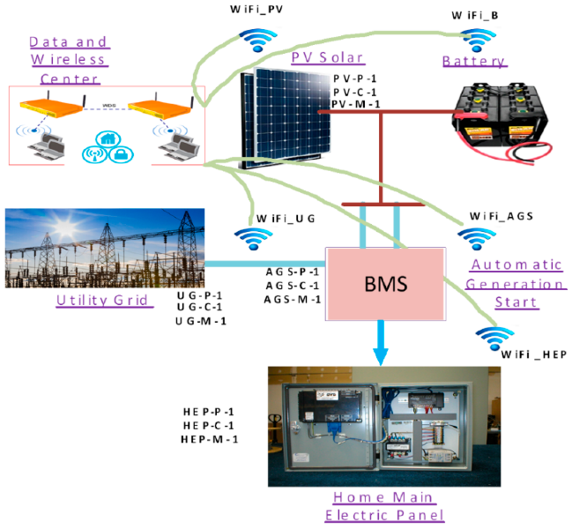***Introduction***:

Battery Management Systems (BMS) have emerged as indispensable components in the realm of rechargeable batteries, particularly in applications such as electric vehicles and energy storage systems. BMS acts as an electronic control system that monitors, regulates, and optimizes the performance of batteries. This report aims to provide a comprehensive analysis of BMS, exploring its functionalities and highlighting its significance in enhancing battery safety, performance, and longevity. By understanding the intricate workings of BMS, stakeholders in the field can make informed decisions regarding the integration and utilization of this technology.

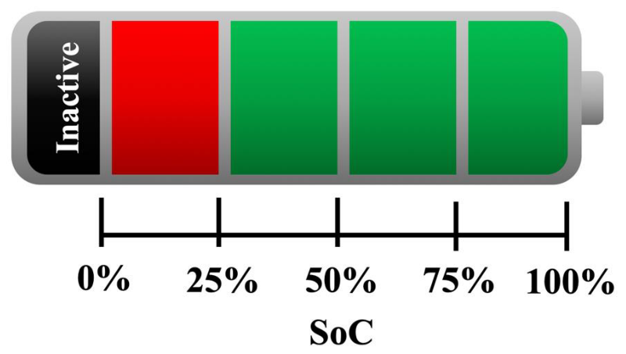***Analysis***:

1. State of Charge Estimation:
   * Methods and algorithms used for accurate estimation.
   * Importance of precise state of charge information in optimizing battery usage.
2. State of Health Monitoring:
   * Parameters considered for assessing battery health and remaining life.
   * Techniques employed for tracking charge and discharge cycles, temperature effects, and aging.
3. Cell Balancing:
   * 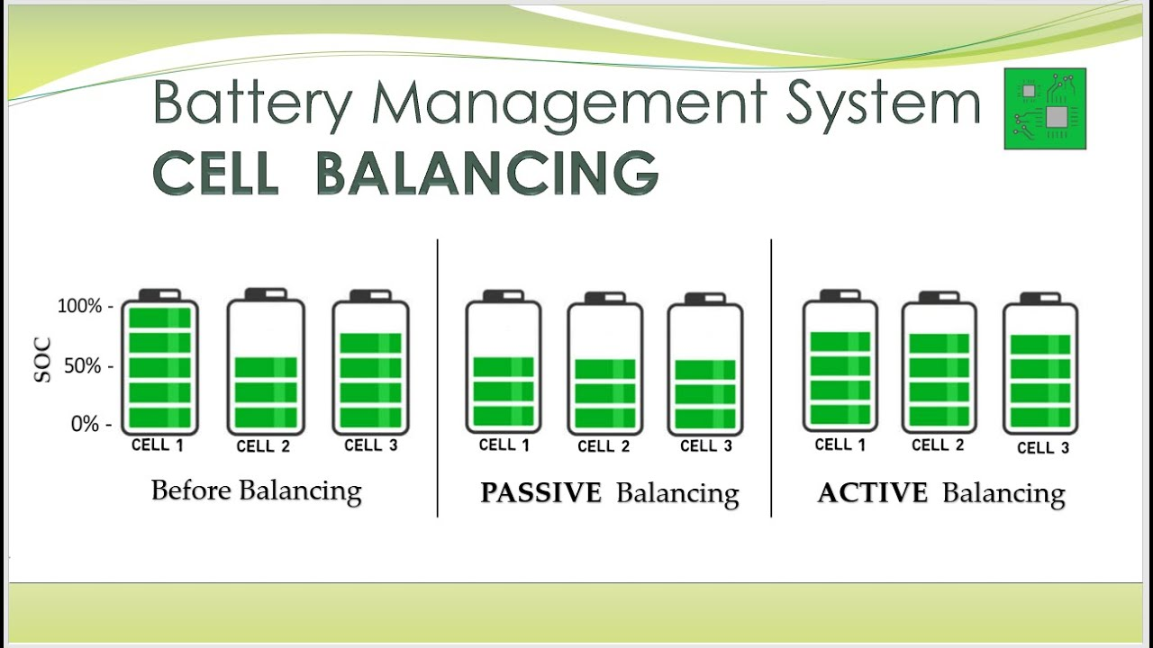The significance of cell balancing in multi-cell battery packs.
   * Techniques employed for equalizing cell capacities and optimizing overall pack performance.
4. Overvoltage and Undervoltage Protection:
   * Detection and prevention mechanisms for overcharging and over-discharging.
   * Role of BMS in protecting battery cells from damage and extending their lifespan.
5. A red and white logo

   Description automatically generatedTemperature Monitoring:
   * Importance of maintaining optimal temperature conditions for battery performance and safety.
   * Implementation of temperature monitoring and control strategies in BMS.
6. Fault Detection and Alarms:
   * Detection of abnormalities, such as short circuits, overcurrent, and thermal runaway.
   * Initiating alarms and protective actions to mitigate risks and prevent catastrophic failures.
7. Communication and Data Logging:
   * Integration of BMS with communication interfaces for data exchange.
   * Real-time information availability for system integration, diagnostics, and performance analysis.

***Conclusion***:

Battery Management Systems (BMS) play a pivotal role in ensuring the safe and efficient operation of rechargeable batteries, thereby enhancing overall system performance in energy storage and electric mobility applications. Through accurate state of charge estimation, state of health monitoring, cell balancing, overvoltage and undervoltage protection, temperature monitoring, fault detection, and communication capabilities, BMS contributes to extending battery life, optimizing energy usage, and 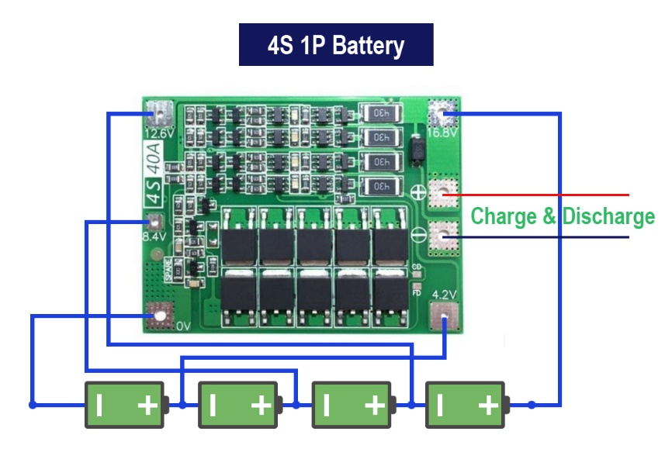mitigating safety risks. The comprehensive analysis presented in this report emphasizes the critical importance of BMS in advancing energy storage and electric vehicle technologies.

***Citation:***

1. What is a Battery Management System (BMS)? – How it Works

<https://www.synopsys.com/glossary/what-is-a-battery-management-system.html>

1. Battery Management System

<https://www.sciencedirect.com/topics/engineering/battery-management-system>

1. What Is A BMS (Battery Management System)?

Battle Born Batteries

<https://battlebornbatteries.com/battery-management-system/>